22nd March 2018

The new Ram 1500 MY19 -Executive Product Information-
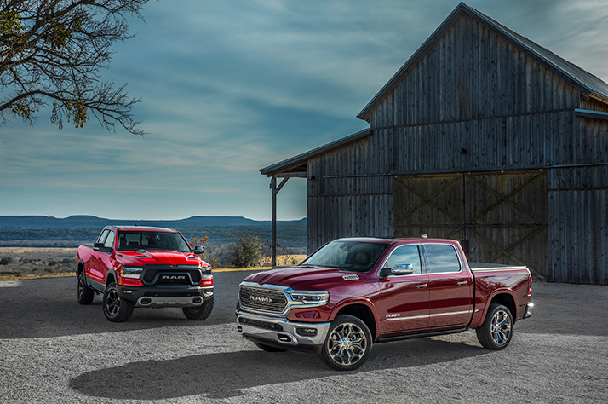

- EMEA area debut for the new RAM 1500 MY19
- Overall weight reduction of nearly 100 kg compared to the previous model
- Ground-breaking design, top quality materials and exclusive technology
- HEMI V8 5.7l 395 HP powertrain with upgraded eight-speed automatic transmission
- Innovative, state-of-the-art technology with award-winning fourth-generation Uconnect system and 12-inch reconfigurable touchscreen display
- Available with the most powerful audio system ever offered in a pickup: Harman Kardon audio system with 19 speakers, 900-watt amplifier and 10-inch subwoofer
- New switch bank, wireless charging dock and up to five USB ports
- 360 degree Surround View Camera with bird’s-eye perspective of the vehicle
- Luxurious, more spacious interior with overall cab length increase of 10 cm
- Updated central console with 12 different compartment layouts
- Lavish safety outfit, including Adaptive Cruise Control (with Stop, Go and Hold) and Forward Collision Warning-Plus and LaneSense Lane Departure Warning-Plus systems

The Geneva International Motor Show welcomed the new Ram 1500 MY19, making its debut in the EMEA region, where the American brand is already very popular. Compared to the previous model, the new Ram 1500 MY19 is larger in size, in spite of weighing nearly 100 kg less. It also features higher load and carrying capacity and an extremely comfortable cab. The major innovations include a 10 cm increase in cab length, and a 12 inch Uconnect display in the middle of the instrument cluster.
Since being launched in North America as an independent brand in 2009, Ram has quickly won a solid specialist reputation, proven by many awards and market successes achieved over these years, thanks to a product range that effectively expresses supreme levels of innovation, capability, efficiency and durability. The two new Ram 1500 MY19 vehicles displayed at Geneva have impressed the public with their awesome size and personality.
Both pickups were equipped with 395 HP 5.7L V8 powertrain, eight speed automatic transmission and 4WD.

Engineering
Compared to the previous version, the new Ram 1500 MY19 has a longer, lighter, more efficient chassis, which is also the strongest the American brand has ever built - with the same impact countermeasures across all configurations, it is made from 98% high-strength steel.
The exclusive front splayed frame rail technology creates a highly efficient energy absorbing structure for all impact modes, including front-offset with frame integration forward of the front tyre. To further improve noise vibration harshness (NVH), new electronically controlled side-frame-mounted active tuned-mass modules (ATMM) work in harmony with an interior active noise cancellation (ANC) system to reduce ambient sounds down to a low 67.1 db. Rear cross members are double sheer welded to the inside and outside of the frame for improved durability and roll stiffness.
New independent front suspension components combine lightweight composite upper control arms, aluminium lower control arms and retuned geometry for improved responsiveness and handling. The front stabilizer bar is relocated behind the front tyres, further improving roll stiffness by 20%. A new front coil-over shock design is standard equipment on all Ram 1500 MY19s regardless of their configuration.
Frequency Response Damping (FRD) Shocks: the FRD technology has found its way into the Ram 1500 MY19 shocks on all four corners. When the vehicle experiences a slower input, common during cornering and heavy braking, the bypass valve is closed for more aggressive damping, which provides additional stability and poise. When driving normally or exposed to faster shock inputs – which is common on rough roads or at higher speeds – the valve will open to soften the damping, giving the driver more comfort, confidence and control. New tailgate in aluminium: it doesn’t only feature damping during opening, but also integrates a lift assist feature.
Aerodynamics: When the Ram 1500 MY2019 reaches 56 km/h, the active front air dam automatically extends downward by 6 cm. The optional air suspension system lowers the truck 1.5 cm, improving overall aerodynamics and efficiency.
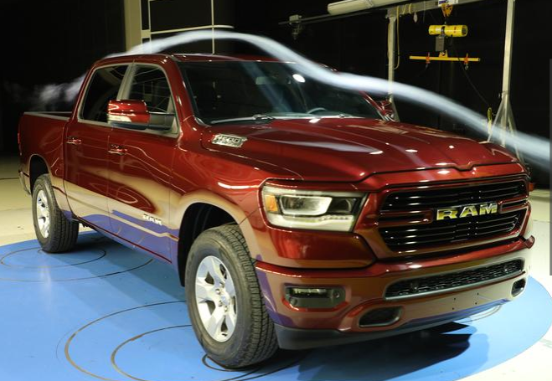
RAM 1500 – wind tunnel profile

Powertrain
Legendary HEMI power: the brawny 5.7-litre HEMI V8 combines the muscle of 395 horsepower and 555 Nm of torque, with performance-enhancing and fuel-saving technologies that include variable valve timing and cylinder deactivation.
With Fuel Saver Technology (cylinder deactivation), the engine control computer turns off fuel and spark, and closes the intake and exhaust valves on four of the engine’s eight cylinders during light load operation, such as highway cruising when full power is not needed. Eight-speed automatic transmission: the 5.7-litre HEMI V8 engine is combined with the upgraded TorqueFlite 8HP75 eight-speed automatic transmissions, with a new generation control computer. There are more than 40 individual shift maps to optimize shift changes and points for fuel economy, performance and drivability.
Off-road: a rugged off-road package (standard on Rebel trims, optional on the rest of the range) features coil spring suspension and a 1.5 cm factory lift. What's more, standard outfit includes automatic hill-descent control (HDC), an off-road-biased rear suspension geometry and unique off-road-calibrated shocks bolster trail capability. The package also includes robust skid plate protection (transfer case, steering, engine and gas tank). On top of that, hefty tow hooks feature wide bumper openings to ease use.
Axles: the new model's innovations include an electronic locking differential - included in the off-road package and therefore standard on Rebel trims and optional on other versions - enabling the driver to lock or unlock the differential as required to deliver maximum traction when needed.
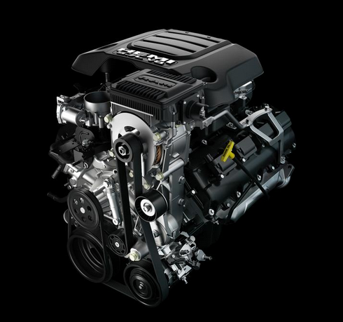 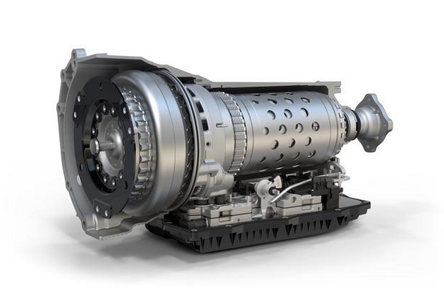
RAM 1500 – 5.7 liter V8 with TorqueFlight eight-speed transmission
Uconnect
Designed to be the most technologically advanced pickup ever, the new Ram 1500 MY19 is loaded with an array of innovative and state-of-the-art technology combined with the fourth-generation Uconnect system that offers new features. Key items include an exclusive, completely configurable, easy-to-use 12 inch touchscreen display (standard on Long Horn and Limited trims) and the most powerful audio system ever offered in a pickup: a 900 watt Harman Kardon audio system with 19 speakers.
The bonded flush 12-inch reconfigurable touchscreen with tailor-made graphics makes personalization easy with the new split-screen, operating two different applications for desired configuration, such as HVAC and Apple CarPlay/Android Auto controls, or one application, such as navigation across the entire 12-inch touchscreen.
Available for the first time on this model is a 360-degree Surround View Camera system providing a birds-eye view via four cameras positioned around the vehicle to create a fully stitched image. Customers who prefer not to use the touchscreen for HVAC will find redundant controls located on both sides of the display for convenience. The new model also offers Uconnect 4 with or without navigation on an 8.4-inch display and Uconnect 3 with 5-inch display.
The most powerful audio system ever in a pickup: the all-new Ram 1500 MY19 offers four audiophile-quality audio systems to immerse passengers in the ultimate sound experience, including Alpine speakers and a class-exclusive premium audio system: a sophisticated Harman Kardon system with 19 top quality speakers, 900 watt surround-sound amplifier and 10-inch subwoofer.
Compatible device connectivity: to ensure that passengers remain conveniently connected, Ram 1500 MY19 owners can manage their personal device connectivity with a plethora of electronic charging options. Located in the re-imagined centre console, a wider docking area offers an all-new optional integrated wireless charging pad (standard on Limited and optional on Longhorn and Laramie trims) that can hold a small tablet or multiple smartphones. To keep devices charged, there are five USB ports.

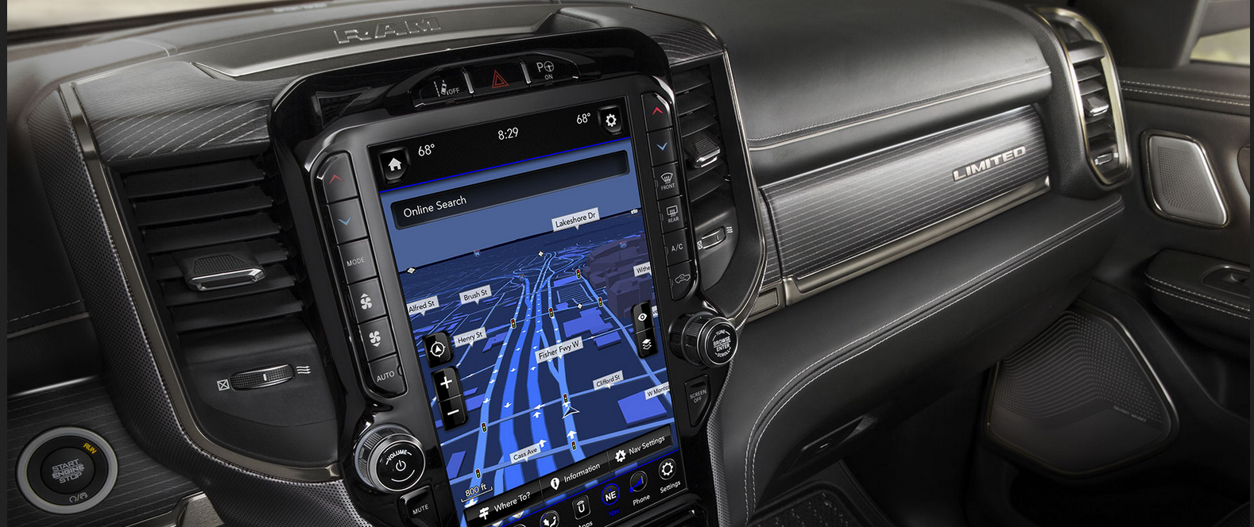
RAM 1500 – Uconnect with 12-inch screen

Design
The new Ram 1500 MY19 is lighter, longer and wider. Ram 1500 MY19’s wheelbase and cab are 10 cm longer, giving the truck improved proportions and better aerodynamics. The model clearly retains shapely body lines with a larger and more aggressive, forward-leaning, front grille opening.
A new panoramic opening sunroof of 85 by 110 cm is also available, giving passengers a spectacular 1 square metre of sky view and additional natural light. Surrounded by the largest cab in the segment, the Interior Design Team brought unique colours and premium materials to each trim level of the new Ram 1500 MY19.
The re-imagined centre console offers more than 12 different storage combinations. At the centre stage, a wider docking area with optional wireless charging can hold a small tablet or smartphone. The three-position sliding cup holder tray can be stowed under the centre armrest to reveal a deep storage tub designed to hold a 15-inch laptop. Lifting the lid of the centre armrest also reveals an additional lined storage compartment sized to fit a tablet and/or hang a full-size file. At the rear of the console, there are two additional cup holders, which include a tablet holder for rear passengers.
Compared to the previous model, the new Ram 1500 MY19 has a more spacious cabin, a flat-load rear floor and a second-row with eight degrees of slide-recline excellent leg room (115 cm). Additionally, folding up the rear bench seat reveals 20 litres of additional storage space with under-seat compartments which, with a clever fold-out feature, doubles to 40 litres.
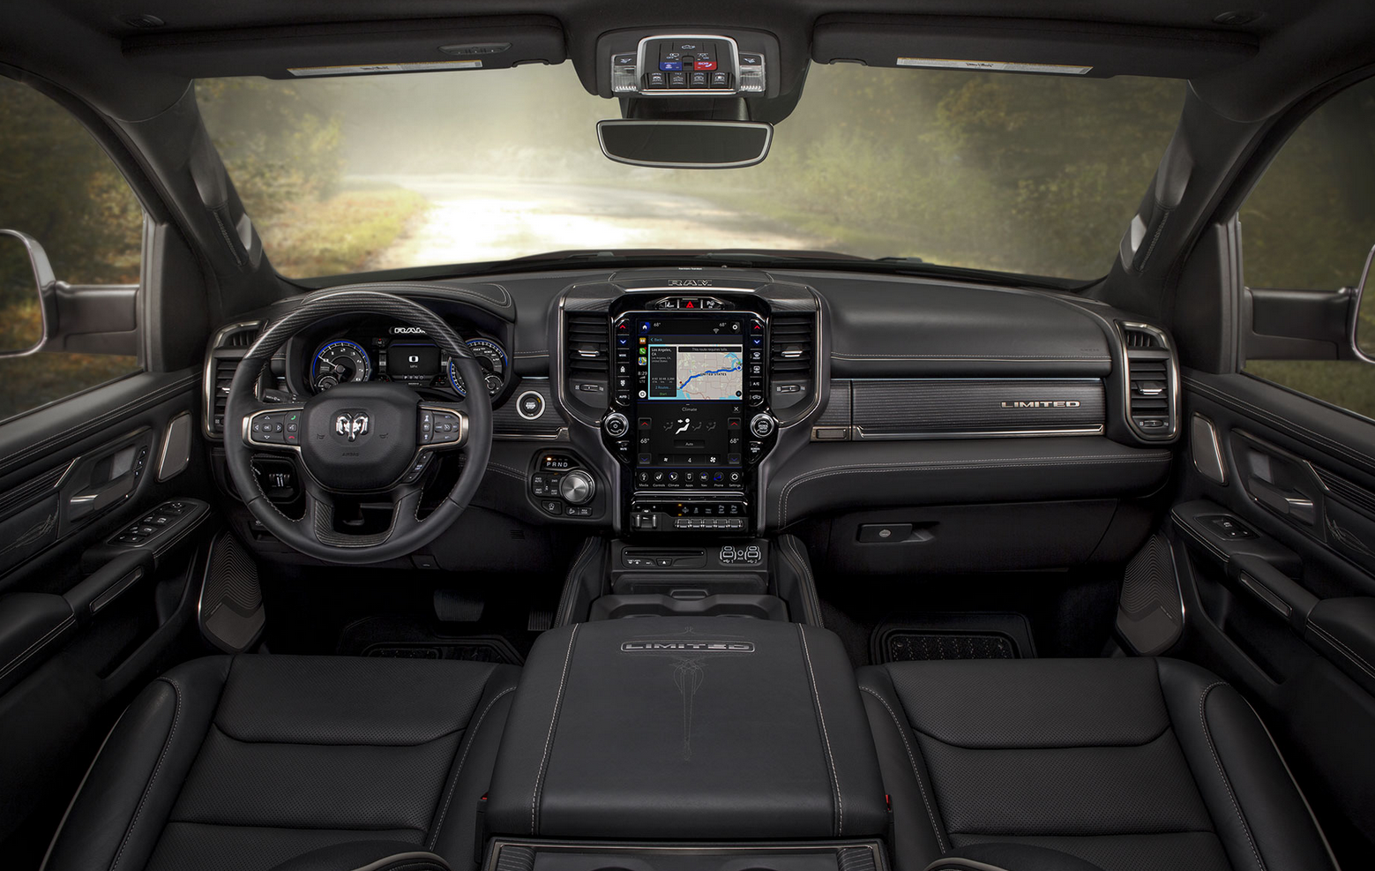
RAM 1500 Limited, interior

Safety and security
The new model offers the very latest materials and technologies for safety and security. The end result is 100 kg less overall weight, hand-in-hand with greater ruggedness and strength.
The many safety devices offered on the new RAM model include:
- Adaptive Cruise Control (ACC) with Stop, Go and Hold: helps maintain a driver-adjustable distance between the vehicle and the one in front of it, and can bring the vehicle to a controlled stop and hold it there.
- Adaptive Front-lighting System (AFS): points headlamps in the planned direction the vehicle is travelling using steering wheel input to point light around turns, driveways and car-parks
- Advance Brake Assist: if inadequate force is applied to brakes in response to a signal from Full-speed Forward Collision Warning-Plus, Advance Brake Assist increases brake force automatically
- Blind-spot Monitoring (BSM): uses dual ultra-wideband radar sensors to aid the driver when changing lanes or if being passed by or passing unseen vehicles. The system notifies the driver of vehicles in their blind spot via illuminated icons on the side-view mirror. BSM also includes easy-to-use trailer coverage.
- Brake assist: in an emergency brake situation, the system applies maximum braking power, minimizing the stopping distance.
- Forward Collision Warning-Plus: utilizes radar and video sensors to detect whether the Ram 1500 MY19 is approaching another vehicle or large obstacle in its path too rapidly, and warns or assists the driver in avoiding/mitigating the incident.
- LaneSense Lane Departure Warning-Plus: leverages electronic power steering EPS) to deliver a torque input to alert and assist the driver with corrective actions.
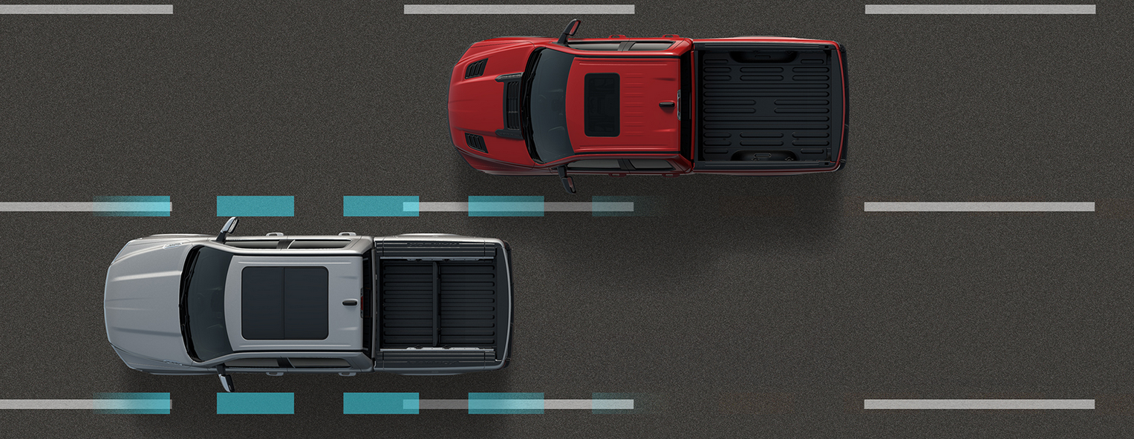
RAM 1500 LaneSense Lane Departure Warning

- ParkSense Parallel/Perpendicular Park Assist: ultrasonic parking sensors on the bumper guide the driver into the parking space. The system automatically controls steering-wheel angle, while the driver controls gear position, brake and accelerator. Parallel parking is possible on either side of vehicle by selecting the direction with the turn signal; for perpendicular parking, the vehicle backs itself into space
- ParkSense park assist with reverse stop: the system utilizes ultrasonic sensors at low speeds in reverse to detect stationary objects. The system provides haptic feedback to the driver, with an application of the brake if a collision is imminent.
- Rear Cross Path (RCP) detection: this system warns drivers backing out of parking spaces of traffic moving toward their vehicle. It activates whenever the vehicle is in reverse. The driver is notified of vehicles crossing behind via illuminated icons on the side-view mirror and with an audible chime.

- Surround View Camera: uses four cameras positioned around the vehicle to provide a bird’s-eye perspective of the vehicle and its immediate surroundings. Drivers can also select other views, including front or rear cross path.

- Tailgate power release and passive entry: allows the operator to release the tailgate using the key fob or unlock automatically with combination of key fob presence and hand motion of the under tailgate handle.
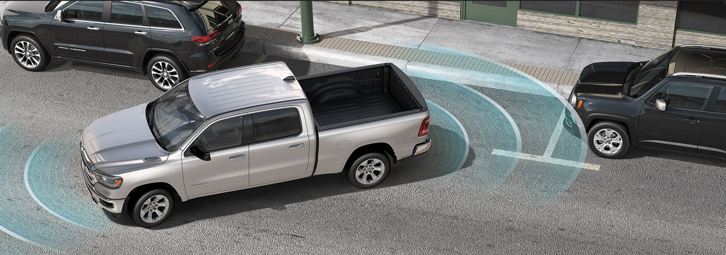
RAM 1500 ParkSense

For more information and images please visit:
https://media.agtimport.eu/photos-ram-2019/

About AGT Europe
AGT Europe is an official importer of Dodge and Ram Trucks in Europe. Working with the manufacturer since 2008, AGT was the first authorized importer for Dodge and Ram Trucks and has been market leader ever since. AGT supports a wide retail and service network of partners specialized in Dodge and Ram.
More information about AGT Europe can be found at www.agtimport.eu and www.uscarimports.eu

About Ram Trucks Brand
Since its launch as a stand-alone division in 2009, the Ram Trucks brand has steadily emerged as an industry leader with trucks that are proven to last. Creating a distinct identity for Ram trucks has allowed the brand to concentrate on core customers and the features they find valuable. Whether focusing on a family that uses a Ram 1500 day-in and day-out, or a business that depends on its Ram commercial truck capabilities, Ram is the right choice. Ram aims to be the best through its commitment to innovation, capability, efficiency and durability. Ram Trucks invests substantially in its products, infusing them with great looks, refined interiors, durable engines and exclusive features that further enhance their capabilities.

About Dodge//SRT
Dodge//SRT offers a complete line-up of performance vehicles that stand out in their own segments. Dodge is FCA North America’s mainstream performance brand, and SRT is positioned as the ultimate performance halo of the Dodge brand, together creating a complete and balanced performance brand with one vision and one voice. For more than 100 years, the Dodge brand has carried on the spirit of brothers John and Horace Dodge, who founded the company in 1914. Their influence continues today.

Contacts for media inquiries:

Europe Germany
Eric Nève Anja Wente
eric.neve@agtimport.eu anja.wente@agtimport.eu
+41 79 195 33 48 +49 1516 511 7778

France Switzerland
Marie-France Mutti Eric Nève
marie-france.mutti@agtimport.eu eric.neve@agtimport.eu
+33 6 62 58 45 77 +41 79 195 33 48

